

***Ready to***

***Take a***

***Challenge?***

The journey to freedom, safety and healing can feel very long and challenging for survivors. And the journey to secure the funding to provide crisis and support services and prevention education can be uncertain and uphill. **We need your help.** Take the Power of 10 Team Challenge!



***The Power of 10 Team Challenge***

10 x 10 x 10 = $1,000!

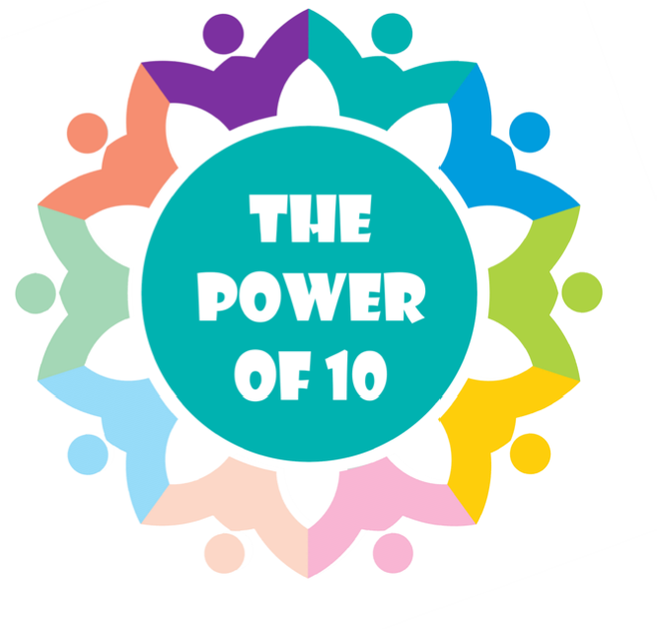

**Set a goal to be a thousand-dollar team!**

1.

Ask at least 10 people to be on your team

2.

Ask those 10 people to ask 10 people

to pledge $10

3.

You will have reached $

1,000!

**$1,000 covers the cost of our 24-hour**

**crisis and support line for 2 months!**

**Once you’ve set your goal as a team, tell everyone.**

**People want to help you reach your goal if they know you have one!**

As a Power of 10 Team Leader, you will be joining with hundreds of other community members who know that, together, we can do what might seem impossible...**meet or exceed a goal of $100,000** to ensure that TPN can provide FREE services 24/7/365, and continue our mission of…

*Preventing Violence, Promoting Respect, Strengthening Lives*

*Call or email us with your success stories as you recruit and fundraise, and you might see your tips in our next Team Leader update! Email us at: kerry@turningpointsnetwork.org*