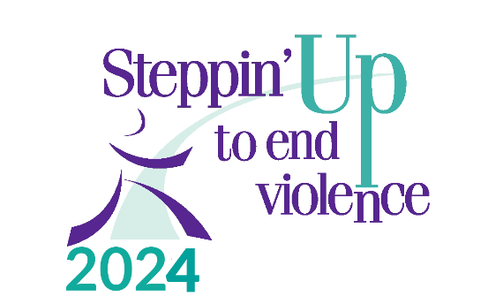

Participant Pledge Form (optional)
Saturday, May 4th at 9 AM, Claremont Middle School
Use this form to keep track of your donations.
Additional forms and info available at www.turningpointsnetwork.org.
If you are fundraising as part of a team, please get your collected cash or checks to your team leader to turn in to TPN.
Team Member:_____________________________________________________
Phone:___________________________________________
E-mail Address:____________________________________
Address:__________________________________________
________________________________________
Team Name:_______________________________________________________
Team Leader’s Name:________________________________________________
If a business or organization would like to be listed as an Event Sponsor (vs. donating to an individual participant or team),
please have them call TPN at 603-543-0155.
***MAKE CHECKS PAYABLE TO: TURNING POINTS NETWORK OR TPN***

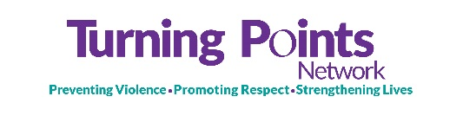

Sponsor | Address  (Street, City, State, Zip) | Donations Raised
 |  | Cash/Check | + JustGiving | + Outstanding Pledges | = Total
i.e. Betty Smith | 22 Walk Avenue, Claremont, NH 03743 | 50.00 | 25.00 | 10.00 | 85.00
1.
2.
3.
4.
5.
6.
7.
8.
9.
10.
11.
12.
13.
14.
15.
TOTAL:

