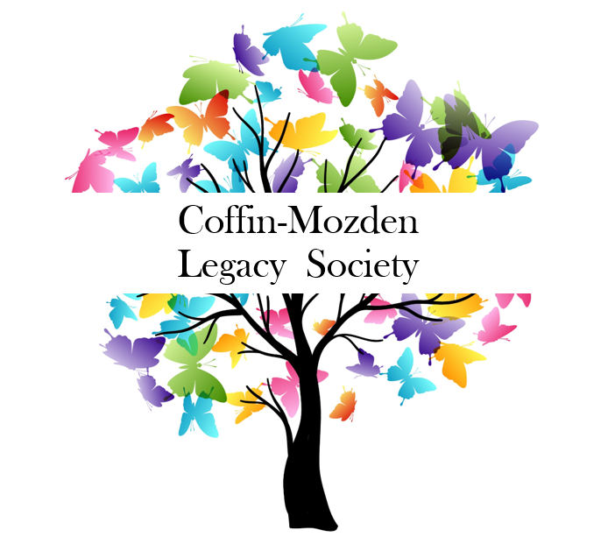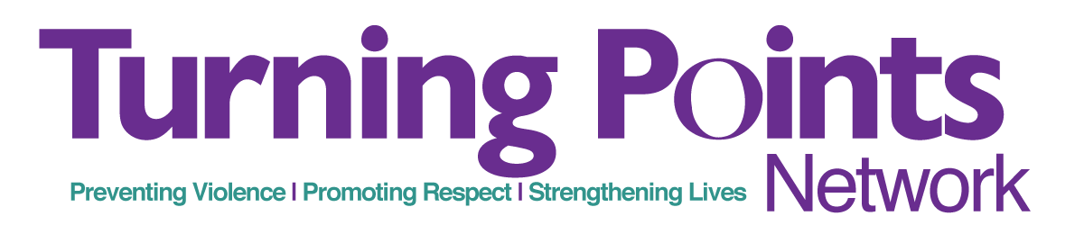

Confidential Letter of Intent

Thank you for informing us of your intention to include Turning Points Network
in your estate plan. We are pleased to welcome you to The Coffin-Mozden Legacy Society.

All information provided below will be treated confidentially, will be used for Turning Points Network’s internal purposes only, and is not considered to be a legal or financial obligation. The nature/size of your gift will be kept confidential.

Please indicate your preferences below:

Date Name(s)______________________________________________________________________

Address________________________________City_____________State______Zip _________
Email_____________________________Cell________________Home___________________

Email_____________________________Cell________________Home___________________

I/we are willing to be listed as a Coffin-Mozden Legacy Society member
I/we prefer to remain anonymous for this gift

As an indication of my support of Turning Points Network, I am pleased to confirm that I have made a provision as follows:

Please check all that apply:
❑ Bequest provision in my/our Will or Living Trust
o Bequest is a specific amount
o Bequest is stated as a percentage or percentage of the residuum
o Bequest depends upon a contingency
Contingency provision:__________________________________
❑ Establishment of a Charitable Remainder Trust
❑ Beneficiary Designation (e.g. qualified retirement plan, commercial annuity, or another vehicle.)
❑ Life Insurance Gift
❑ Real Estate
❑ Gift of Stock
❑ Other

Additional Information: ____________________________________________________

_______________________________________________________________________

Thank you for supporting a future free from violence. Please return this form to:

Turning Points Network
c/o Development Director
11 School Street
Claremont, NH 03743

